
Best Practices

The Concierge Assistant

Working with Reservations

Overview

The Reservation Piece is designed so you can check availability some of the hotel’s resources without transferring the guest or making additional calls for example, hotel car, cabana, kid’s club. We can use the availability feature as a stand-alone system or combined with the logbook system.

Availability Process
The Logbook Entry is the tracking component
The Reservations System is the availability
Making decisions to confirm or deny availability
Printing confirmations and itineraries

There are two places to access the availability system:
A logbook entry or the “Others” screen

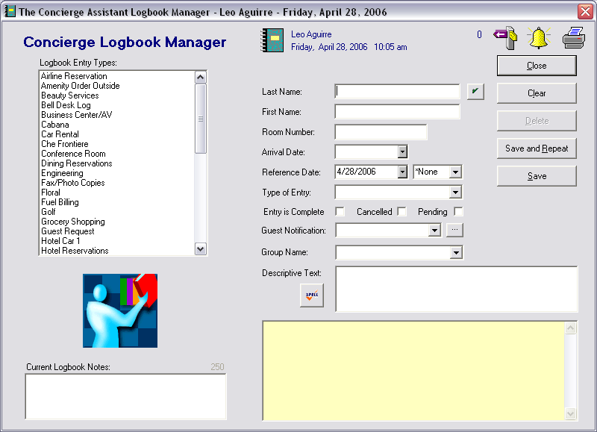
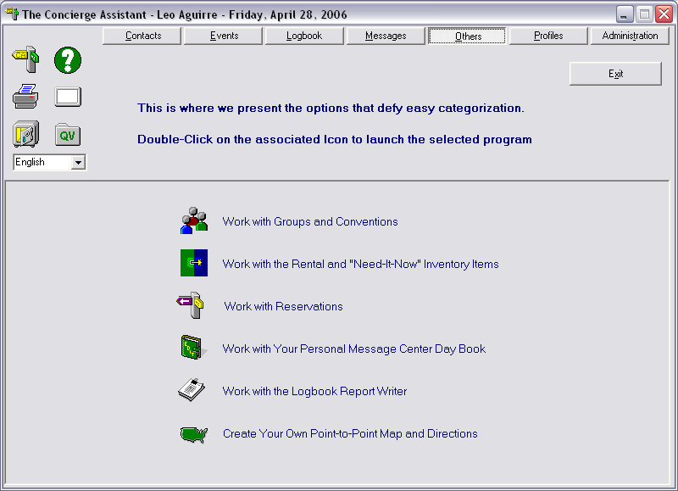

Setup the Process

If we are using the Reservation System combined with the Logbook System, the two categories must have the same name.

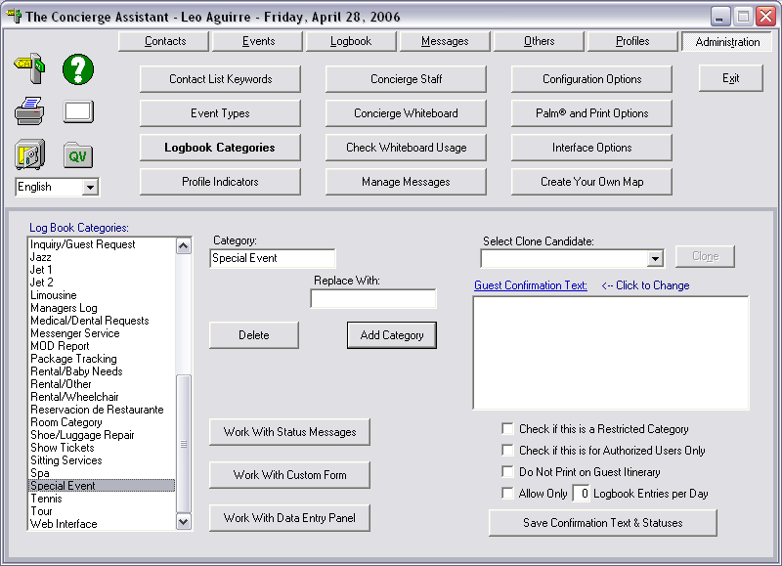
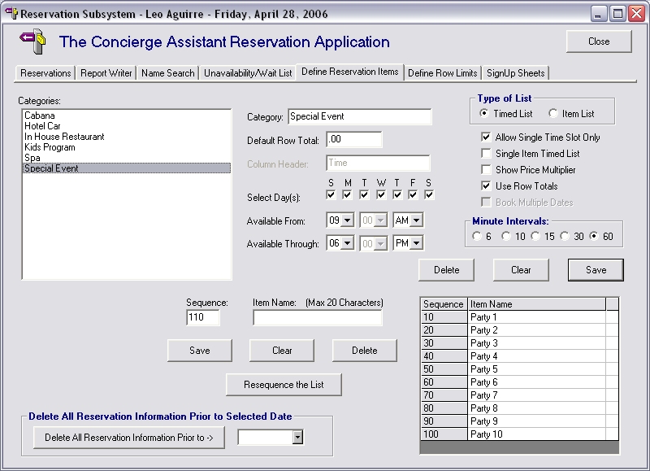

Define the times and the sequence items we need to create the availably grid:

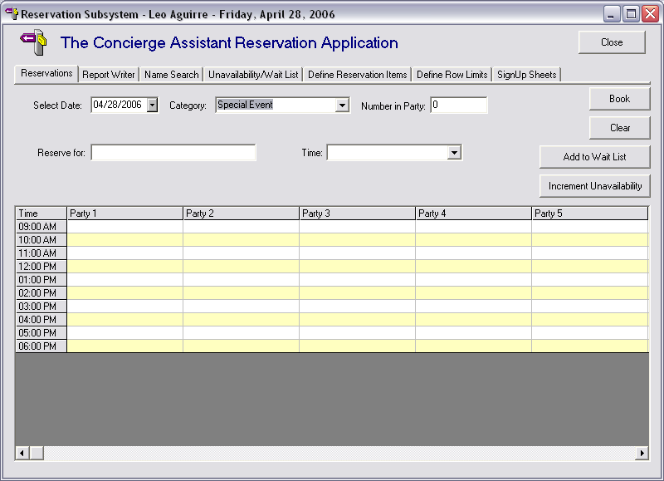

The availability Process

Step 1
Add a logbook entry for Special Event. You may see the availability by double clicking the icon in either the Guest information form or the Data entry form

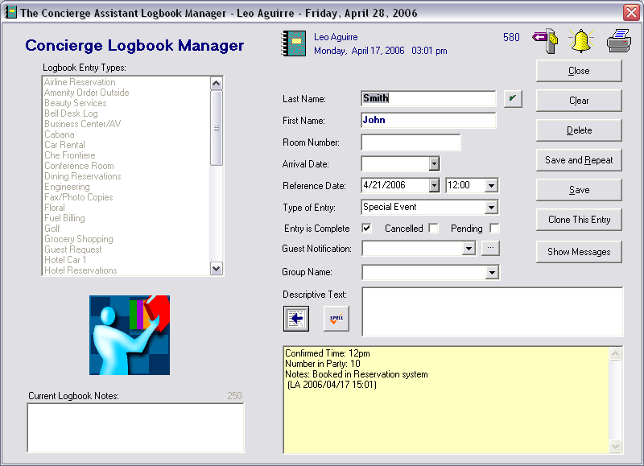
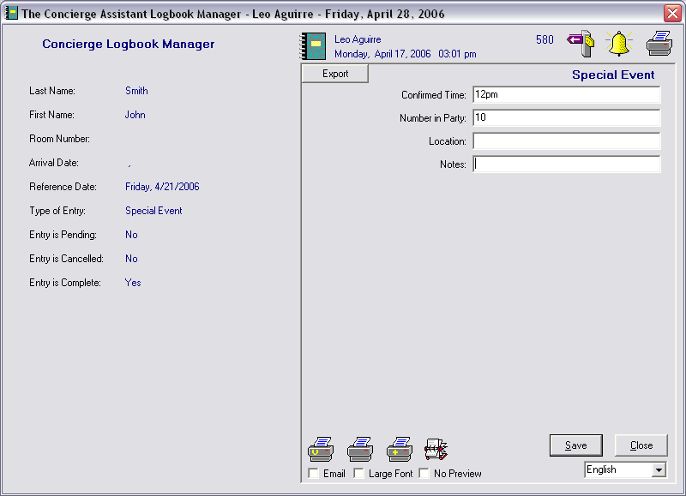

You will be displayed the availability date for the date of the logbook entry. The last and first name of the guest and number in party will be pre-populated for you:

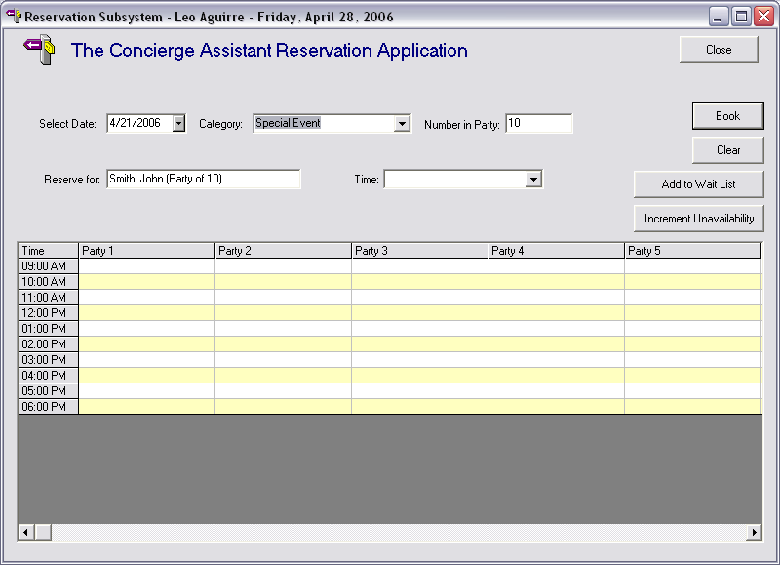

You can select an availability slot by double clicking the desired cell in the grid and then selecting “Book”

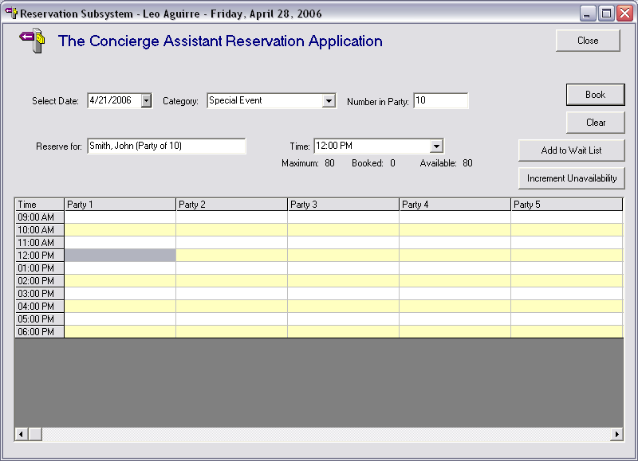
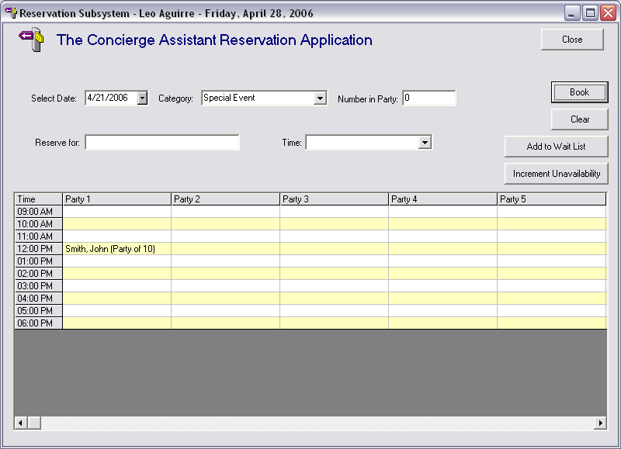

The last step is to update the Logbook Entry so everybody knows that you booked this in the Reservation System.
